Volunteer Notes
For Katsushika Hokusai
(Cat-sue-shee-kah Ho-coo-sigh)
There are two project choices, choose one. Items Needed:

Art Paper (1 per)
Watercolor paper (1 per)
Boxed watercolors (15)
Red paintbrushes (12)
Pastels or crayons (15 sets)
Pitcher for water if no sink Paper towels
For Option #1:
Bubble solution: (see link below for recipe and instructions)
Blue Tempera Paint
Water
Dishwashing liquid
Bowl for bubble solution
Straws (1 per)
For Option # 2:
Sea Salt (a pinch per student is all it takes
Cups (1 per student, plus 8 extra for salt)

Concepts being taught: Please be able to understand and discuss these concepts with the students.
Mixed Media-. A piece of art using more than one medium; i.e. water color paints with pastels, salt or bubble solution, on watercolor paper!
Emphasis: The principle used to focus attention in a composition, using contrast (light vs. dark, large vs. small), lines, placement or isolation to draw the eye to the center of interest. In Hokusai’s work on slide 8, emphasis is placed on Mt. Fuji as the intended focal point, emphasized by being darker, triangular in shape and solid and unmoving, placed alone in the background/ upper portion of the picture. Everything else is rounded and shows movement.
Focal point: The first thing the eye sees when viewing an artwork. This can be created using a contrasting color, placement, size or lines leading to the object of interest. See slides 3 (warm vs. cool colors) and 6 (all lines lead to, and figures bend towards the Mt.). Slide 12 needs a F.P.
Other Notes:
Please be sure to read through all instructions with the students before they begin any project.
The art paper is to sketch out ideas first before committing them to the ONE piece of watercolor paper.
If doing choice # 1, remember to use only on “water” areas.
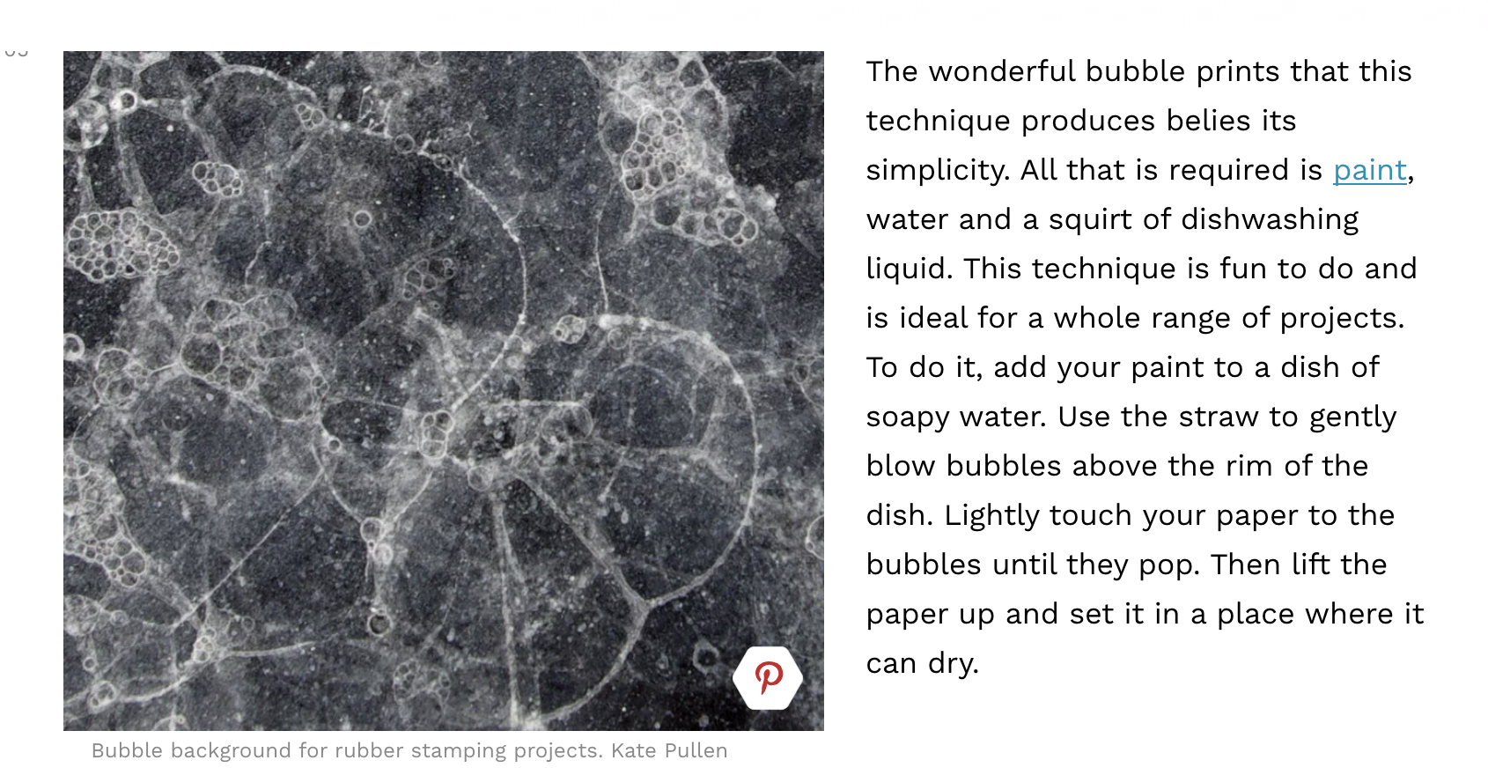
Choice # 2 requires very little salt, and only along the crests of your waves to make “spray”. Have fun!

